CMP301 Graphics Programming with Shaders Coursework Proposal – Cameron Wiggan

# Overview

My cmp301 project will be a constructed scene that will resemble that of a tropical island. This scene will demonstrate my understanding and use of shaders through the use of vertex and pixel shaders to create a surrounding ocean that will move according to a sin algorithm and will reflect any light in the scene in a realistic specular fashion. The island will be constructed using a displacement heightmap and the scene will have properly implemented lighting, shadows and a bloom effect from the lighting that will act as the sun. Finally, if time constraints allow I would like to implement a shader to create a grass like texture on certain parts of the terrain

# Plan & Visual Diagram

My plan is to build the island landmass using a simple displacement map which will then have the vertex normals applied to get further detail onto the model. Conveniently for me land is very traditional in nature going from the ocean to a beach and then onto a grassy plain. This allows to simply setup a shader to change the colour of the model as it increases in the y-axis for the actual island. The ocean itself I will handle using a created plain sitting below the terrain and then having constantly updating sin wave-based movement to mimic the waves. I will then start implementing the lighting into the scene starting with a large directional light to act as the sun which lead into the adding of a specular value to the ocean which will update along with the ocean planes current shape. I will then continue adding any other pieces of lighting and begin loading appropriate models such as palm trees and a little hut in the centre of the island. Finally, I will implement a bloom post processing effect and correctly implement the shadows of the models. By this point there should also be a GUI to change certain values relating to the scene such as the waves height and spacing for example. If time allows for it I would also like to create a shader to create shader to create blades and render blades of grass on the island.

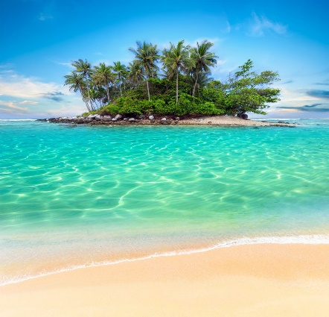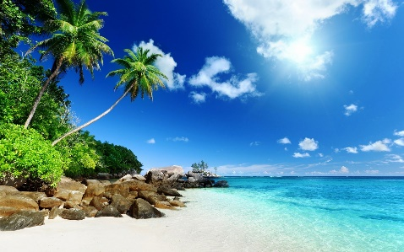

Diagram Plan for how the project

Inspiration for the project 2

Inspiration for the project 1

# Chart Description automatically generatedTimeline

Below is a Gantt chart to show the timeline and plan of my project.

# Techniques

The techniques I will use in the project will consist of the following. Vertex and pixel shaders, vertex manipulation, height maps, Standard lighting techniques, shadows, tessellation on the terrain, post processing bloom effect, specular and attenuation values, normal calculation for lighting on the terrain, UI that updates the scene with new values and finally correctly applied textures.

# Resources

Here are a list of the resources I have at the time of writing that I plan on using in the coursework(I will also make use of any of the lab theory and code provided).

<https://protasovnn.com/2021/02/01/Unity-urp-hlsl-grass-shader/>

<https://www.shadertoy.com/>

Practical rendering and computation with Direct3D 11 by Jason Zink

Real-time 3D rendering with DirectX and HLSL : a practical guide to graphics programming by Paul Varcholik